**MY DevOps PROJECT DOCUMENTATION  
  
GIT COMMANDS TO ADD CODE TO THE REPO.**

* git init
* git add.
* git commit -m "Initial commit: Adding my project files"
* git remote add origin <remote_repository_url>
* git push -u origin master

**ANSIBLE**

* Launch 3 hosts/server tagged:
  + Ansible server;
    - **Install Ansible on Ubuntu 22.4**.
      * sudo apt update
      * sudo apt install software-properties-common
      * sudo add-apt-repository --yes --update ppa: ansible/ansible
      * sudo apt install ansible.
* **Add Jenkins master and slave as hosts Add Jenkins master and slave private IPs in the inventory file, in this case, we are using /opt is our working directory for Ansible.**
  + [jenkins-master]
  + 18.209.18.194
  + [jenkins-master: vars]
  + ansible_user=ec2-user
  + ansible_ssh_private_key_file=/opt/ Devops2.pem
  + [jenkins-slave]
  + 54.224.107.148
  + [jenkins-slave: vars]
  + ansible_user=ec2-user
  + ansible_ssh_private_key_file=/opt/Devops2.pem
  + **Test the connection by using**:
    - ansible –I hosts all –m ping

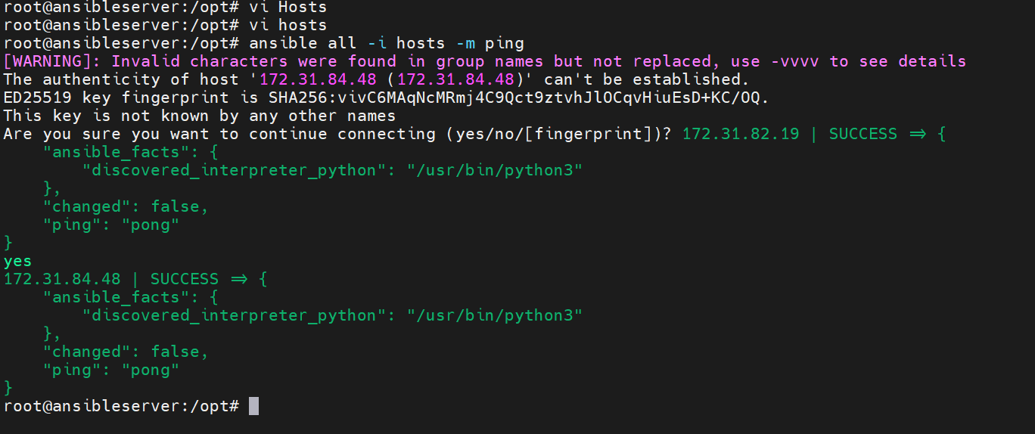

* + Jenkins master
  + Build slave
* Set up Jenkins Environment using Ansible
  + Add the Jenkins repo key to the system
  + Add repositories to the system
  + Install dependencies
  + Install jenkins

So on the ansible server, you will create jenkins-master.yaml file as below:

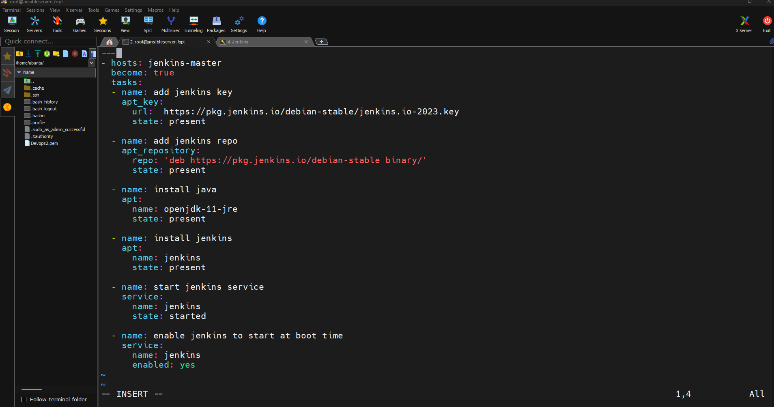

And run this command to dry run install/configure on Jenkins master host: ansible-playbook –I /opt/hosts jenkins-master.yaml –check

But to really configure/install, you will use the same above command but without –check.

NOTE: become: true: This tells Ansible to escalate privileges and become a superuser (e.g., root) to perform the tasks that require elevated permissions, such as installing packages.

**MAVEN SET UP**

* Update the system
* Install java
* Download the maven package
* Extract it
* Add the path to bash_profile(optional)

On the slave host the maven will be configure through the Ansible host as below using   
create vi jenkins-slave.yaml on the ansible host.

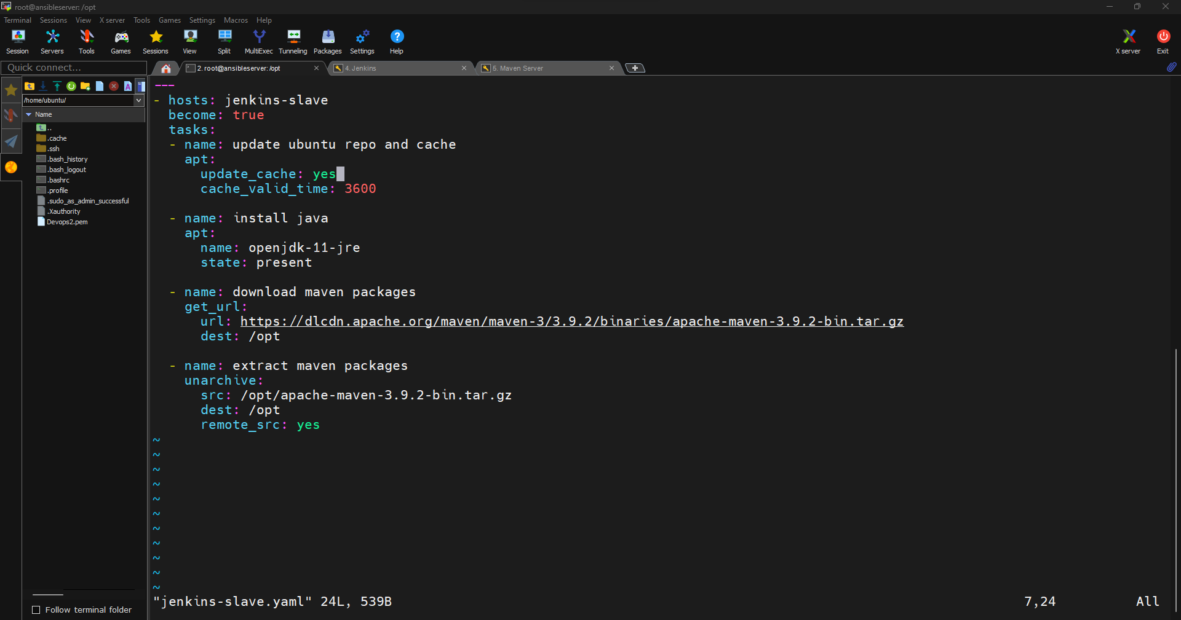

And now run: